In Concert with Full Compass, Bag End and Sennheiser/Neumann
deliver a flawless Opera in the Park performance

Madison, WI – Much can be said for the virtuosity and dynamic sensitivity of opera singers and orchestra members with regard to a flawless performance, but rarely can those accolades be offered in an outdoor concert. Outdoor-venues are hard enough to make sound good, but when you couple the discerning ears of 12,500 opera and orchestra patrons with sound being spread over a wide-open 5 acre space, you have a recipe for disaster. On Saturday, July 21, 2007 when these same conditions were presented to some of the best and brightest minds in sound reinforcement and recording, there was a much different result.

Madison (WI) Opera with the Madison Symphony Orchestra perform this annual event as a gift to the community, but more importantly, to inspire the audience to subscribe to their full season of concerts. If the event was marred by bad sound it could cost the two performing arts groups dearly. They knew the best persons to engage to ensure the quality of the concert - Jonathan Lipp (owner) and the team at Full Compass Systems. In a continuance of the long tradition of giving back to the community, Jonathan decided to offer his and Full Compass’ expert services gratis.

Jonathan called his long-time friends Henry Heine co-owner of Bag End and Mike Pappas Senior Applications Engineer with Sennheiser and Neumann to begin specking out a system that would be powerful enough to cover the large expanse of the park while maintaining a “transparent” presence to the audience, orchestra and singers and allow the opportunity to record the entire performance in 5.1 surround.

The on-stage microphones were kept to a bare minimum. According to Mike Pappas, “with the right devices, you don’t need a lot.” “Instead of buying 40 cheap mics and putting them everywhere, save your money and buy really great mics that are best for the application. This minimalist approach to mic placement properly captures the balance from the conductor. It is up to him or her to truly balance the sound for the recording and the performance. Using this technique doesn’t allow for “punch-ins” or a post-performance fix, but it captures the life of the performance.” Mike and Jonathan chose 4 Sennheiser MKH 800s for the singers because of their neutral and transparent sound. Three MKH 800s were used as overheads for coverage of the entire orchestra, with two Neumann KM 184s used to highlight the harp and percussion sections and a stereo pair of Neumann KM140s set in an ORTF configuration and two Neumann KM184D Solution “Ds” used as “flankers” covered the choir. When portable stages are used outdoors, low frequency resonances from the stage interacting with the sound system can be a problem and are exacerbated by the double basses. To remedy this, the basses used piezo pick-ups and countryman direct input boxes. For audience and ambient sounds, a Neumann KU100 Binaural Stereo Dummy Head Microphone was used because, according to Pappas, “its scary realistic.”
-more-

Because the team was simultaneously recording the event and feeding the FOH mixer, the microphone signals were split before being routed to the recording desk and the recording pre-amps supplied phantom power for both. For the recording, Pappas brought his personal rig including: two Grace 801 R and one Grace 802 phantom power supplies, one Meitner Design EMM Labs DAC8 digital to analog converter, three EMM Labs ADC8 MR IV A/D converters and a Rosendahl “Nano Clocks” Word Clock generator which fed to a Tascam x48 running 24 channels to record. Output of the x48 went to a Mackie SR24-4 mixer for a reference mix. Pappas said, “This recording would not be possible without a really well behaved PA. We are running condenser mics on the whole system and it creates a big, full sound. The challenge is to make the sound non-intrusive and transparent to the audience.”

That is where the expertise of Henry Heine and Jonathan Lipp owner of Full Compass are tested to find that delicate balance. The Front of House system consisted of a Yamaha 01V96 digital console with built-in effects, two clusters of three 1000w powered 2 x 12” Bag End Crystals (run in stereo) that were flown in front of the stage with four TA6000-R front seat fill speakers, two powered 21” and two powered double 18” sub. The electronic crossover for the system was a Bag End Infrasub processor. Upstage monitors were 2 TA6000-R's, flown above the chorus and the floor monitors were 4 Bag End Sapphire's. A Goldline TEF25 Tefpro audio analyzer was used to calculate the 135 ms delay time for two towers set 138 feet in front of the stage where an additional cluster of two stereo1000w powered 2 x 12” Bag End Crystals were stationed on each side. A Shure Brothers P4800 handled the entire speaker matrix.

The two-hour concert went off without a hitch and has met with rave reviews and personal letters of thanks to Full Compass, Bag End and Sennheiser/Neumann from key members of the community.

####

Contacts:
Henry Heine
Co-Owner
Bag End Loudspeakers
v: 847.382.4550
e-mail: henry@bagend.com
Sean McBryde
Marketing and Communications Manager
Full Compass Systems
v: 608.831.7330 x 1335
e-mail: mcbryde@fullcompass.com
Mike Pappas
Senior Applications Engineer
Sennheiser/Neumann
v: 303.988.0976
e-mail: mpappas@qwest.net
Jonathan Lipp
CEO and Owner
Full Compass Systems
v: 608.831.7330 x 1126
e-mail: jon@fullcompass.com

PHOTOS AVAILABLE – http://www.fullcompass.com/news/123.html
Photo credit is: Full Compass Systems
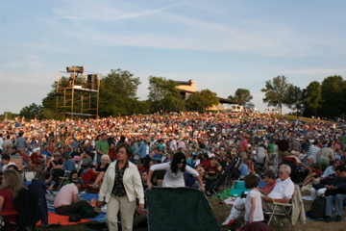
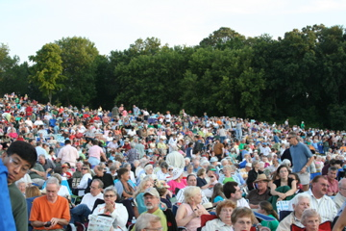

Audienceshot.jpg Audience_shot2.jpg

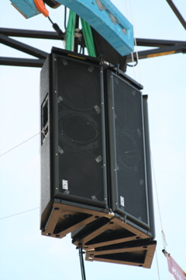
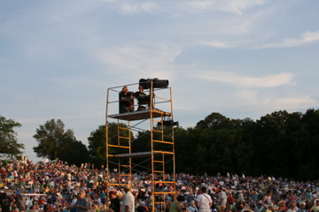

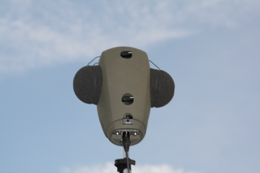
delay_tower.jpg

BagEnd_cluster.jpg

Neu_KU100.jpg

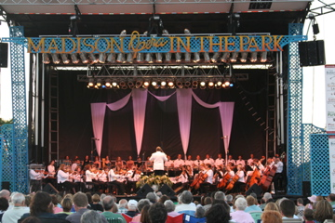
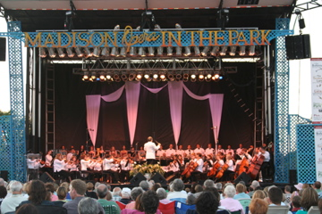

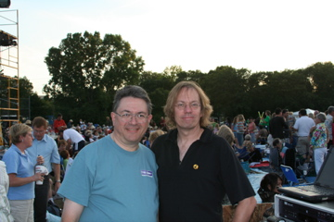
Front_stage.jpg front_stage2.jpg
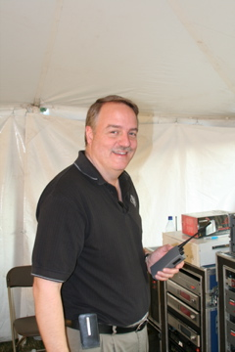

HHeine_JLipp.jpg
Mike_pappas.jpg
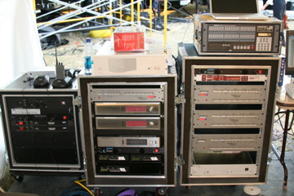
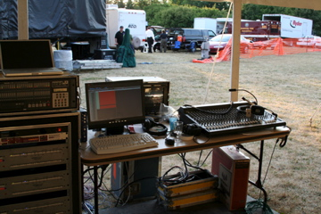

Recording_rig.jpg recording_rig2.jpg

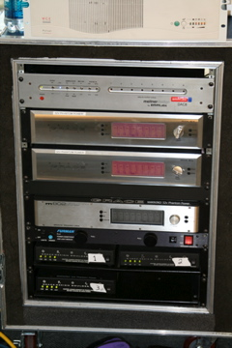

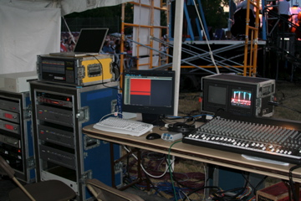

Recording_rig4.jpg

Recording_rig3.jpg

